**Central West Focus Area**

The following information provides an overview of the Central West Focus Area process. For more information, please visit the Central West Focus Area webpage: [www.townofchapelhill.org/centralwest](http://www.townofchapelhill.org/centralwest)

**Purpose**

The purpose of the Central West Focus Area process is for the community to provide their ideas and thoughts about the following:

* Appropriate uses for the area (such as residential, commercial, office, mixed-use, etc.);
* The form (what the buildings and public spaces should looks like); and
* The intensity (how many new uses and buildings are comfortable for the area).

The community’s thoughts and ideas will form a small area plan which, if necessary, will be developed into new zoning regulations for the area. These regulations will help to ensure that the area is compatible with the community’s wishes.

**Area Under Discussion**

The following map provides an overview of the Central West Planning Area and Impact Area:

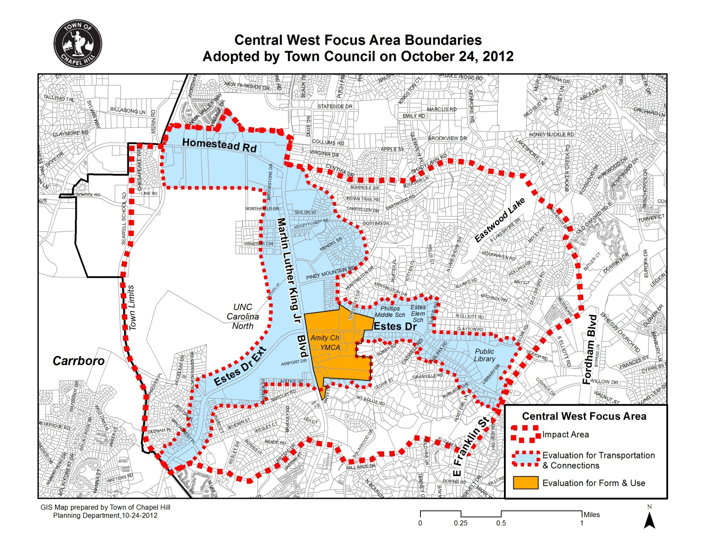

* **Evaluation for Form & Use:** Identifies areas under discussion for potential form and use changes.
* **Evaluation for Transportation & Connections:** Includes areas that may be impacted by potential changes in the “Evaluation for Form & Use Area” and encompasses topics such as Carolina North, transportation issues (including bicycle, pedestrian, and connectivity issues), watershed issues, and others that impact the entire area.

*Note: Discussions about Homestead Road will be a part of the future Area 2: North Martin Luther King Jr. Blvd. Focus Area effort.*

**Background and Steering Committee**

During the Chapel Hill 2020 comprehensive planning process, the Central West Focus Area was identified as a priority for focused discussions due to the known development pressures in the area, its location along major roads, and the existence of vacant land.

With the adoption of the Chapel Hill 2020 comprehensive plan, the Town Council requested that Town staff work with the community to develop a process that would provide an opportunity for more focused discussion that would ultimately provide the Council with additional direction for the area.

In December 2012, the Town Council developed a Central West Focus Area Steering Committee comprised of representatives of residents, UNC Chapel Hill, Chapel- Hill-Carrboro City Schools, Town Advisory Boards (Planning, Transportation, and Bicycle and Pedestrian), and business owners/landowners/non-profits. The Steering Committee began meeting in December of 2012, to address the purpose provided by Council (see above) and to develop a small area plan for the Central West Focus Area.

**Schedule and Upcoming Meetings**

The Town Council has requested that a draft plan be presented to the Council before their last meeting in June of 2013 for Council consideration and guidance. A final plan is to be provided to the Council by December 2013.

Are you interested in being a part of this process? Please join us at these upcoming meetings:

* Steering Committee Meeting: Tuesday, March 12th from 7:00-9:00pm, Location TBD
* Steering Committee Meeting: Thursday, March 21st from 7:00-9:00pm, Location TBD
* Steering Committee Meeting: Thursday, April 4th from 7:00-9:00pm, Location TBD
* Community Report Out: Tuesday, April 9th, Time and Location TBD

**For More Information**

For more information about the Central West Focus Area process and for notices about upcoming meetings, please visit the Central West Focus Area webpage at [www.townofchapelhill.org/centralwest](http://www.townofchapelhill.org/centralwest)

Have questions? Please contact Megan Wooley, Housing and Neighborhood Services Planner, at   
919-969-5059 or [compplan@townofchapelhill.org](mailto:compplan@townofchapelhill.org)

If you would like to be added to the Central West Focus Area email distribution list to receive notifications about meetings and meeting materials, please email [compplan@townofchapelhill.org](mailto:compplan@townofchapelhill.org)