**Obey Creek Questions and Responses**

*Last Revised: October 10, 2014*

The following are questions that staff has received from Councilmembers and community members since the October 1st Council work session. The questions are grouped by topics.

**Section 1: Transportation**

1. Question: What, if any road improvements, including traffic calming and sidewalks, are currently on our list pre Obey Creek?

Response: We are not developing any construction projects in this area that will take place pre-Obey Creek.

**Section 2: Fiscal**

**Question Set #1: Clarification Questions about Fiscal Report**

1. Question: I don't understand (possibly don't agree with) the staff perspective, indicating TOCH Public Works will not incur any increase in their costs due to scenarios.  Please explain further.

Response: Because Scenario 1 proposes privately owned streets, Public Works does not anticipate direct costs for street maintenance, street lighting or traffic sign maintenance.  Some existing budgeted resources will be used to review plans and issue permits for which our cost is offset by the applicable permit fees.  Similarly, because the development is proposing to provide solid waste collection services using privately serviced trash compactors rather than conventional Town serviced dumpsters we do not anticipate direct solid waste collection costs.  The Town does not provide service to trash compactors.  The use of trash compactors, however, significantly increases solid waste collection efficiency in high density development and despite ongoing service costs can therefore be cost effective for the developer/property owner.

Public Works will incur ongoing direct costs, estimated at $48,350, for Scenario 2.  This includes one-time cost of $6,150 for solid waste roll carts, and on-going annual cost (current dollars) of $42,200 for street lighting, solid waste disposal fees and street maintenance (annual life cycle cost).  The amount shown represents the additional direct cost for Scenario 2.  It doesn’t include cost associated with the use of currently budgeted staffing and equipment.  Fees are collected to cover the in-house cost associated with plan review, permits and inspections related to Scenario 2.

1. Question: Fire Dept costs include some amount for capital expenses, why not Police Dept. (for substation...)?  Also, what about the costs related to false fire alarms that TOCH Police respond to?

Response: Costs for Police and non-apparatus Fire capital costs are included in the 13% Capital overhead rate described on pages 7 & 8 of the staff memorandum titled “Obey Creek Project Preliminary Fiscal Impact Report.”

1. Question: The analysis assumes that the streets will remain private. It is my understanding that in most of these projects (e.g., Southern Village and Glen Lennox), the streets are transferred to the Town upon completion. Is keeping the streets private meant to be an item of negotiation? If the streets do transfer to the Town, I would imagine that a significant amount of funds would need to be allocated around 15-20 years out to cover repaving, etc.

Response: The design of Scenario 1 proposes a network of privately owned and maintained streets that access only internal components of the development.  This is similar to other recently constructed internal private streets in the East 54 development and the commercial center of Meadowmont.  Because the proposed streets will not be used by Town refuse collection vehicles and do not connect to any adjoining properties we believe it is reasonable that they be privately owned and maintained and we do not anticipate a compelling reason for future transfer to Town ownership.  Private ownership provides the developer with additional flexibility in the design of the streets and associated improvements (sidewalks, streetlights, site furnishings etc.) and reduces costs to the Town.   As designed in Scenario 1, we support the proposal to provide private streets.

1. Question: On page 3 of the fiscal memorandum:  The cost of transit for the proposed development is estimated to be about $262,000 per year.  Unfortunately, this is only enough money to pay the operating costs of one bus for eight hours per day. Yet, the traffic analysis provided by the developer suggests that 2500 people will ride the bus to-and-from Obey Creek each day. These numbers don’t line up.

Response: The $262,000 number only represents the expected Town revenues associated with the dedicated property tax that sis expected to be dedicated to new service needs. This does not take into consideration the role of the Transit’s funding partners or the existing serve provided to the area. An analysis of how service needs may be met will be provided at a subsequent meeting.

*Note: The Council will have the opportunity to discuss transit questions during future “preparation sessions,” possibly on October 30th.*

1. Question: I'd like to hear from CH Transit Director, regarding revenue projections vs cost of services related to development scenarios.

Response: We have shared this question with Brian Litchfield, the Transit Director, and the Council will have the opportunity to discuss transit questions during future “preparation sessions,” possibly on October 30th.

1. Question: On page 10 of the fiscal memorandum: You’ll see that one-time revenues for building permits and fees are estimated about $1.1 million, but the one-time costs of inspecting the construction will be only $10,000.  For 1.6 million square feet.

Response: Town staff is still developing a response and will share this with the Council as soon as it is available.

1. Question: Last, none of this analysis includes capital costs to the town:  Will new buses be needed for transit? Will the fire station need to expand?  Will the fire department need a new ladder truck to accommodate the taller buildings?  None of these expenses are addressed in the memorandum.

Response: The cost analysis includes a 13% overhead cost for capital investment based on the proportional size of the debt management fund to our operation budget. See pages 7 & 8 of the staff memorandum titled “Obey Creek Project Preliminary Fiscal Impact Report.”

1. Question: In past twenty years how as property tax and sales tax revenue changed? Graph?

Response: The attached graphs and data tables (see next page) show the property and sales tax as a proportion of General Fund revenues. As the graphs show, both have remained relatively stable over the last twenty years as a percent of total revenues. This however does not tell the entire story since property taxes are affected by rate increases and sales taxes are not. Also, adjusting for rate changes is complicated by the fact that revaluations drop the property tax rate periodically.

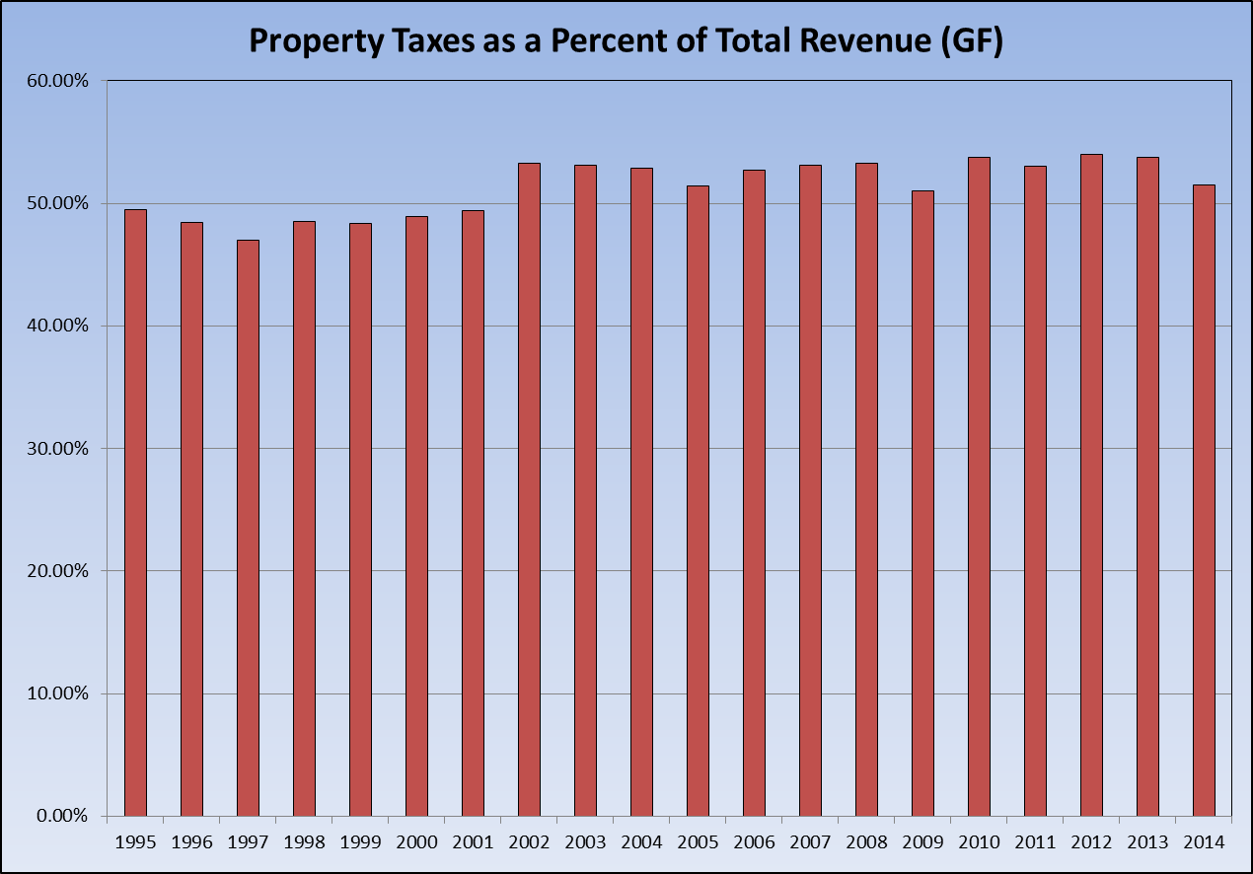

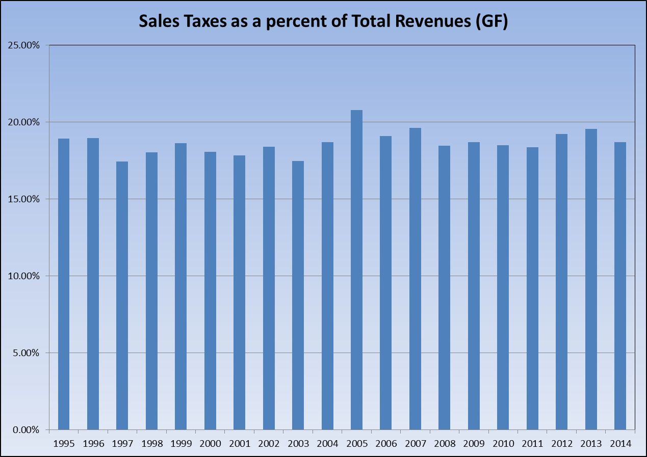



1. Question: Can we pin-point specific changes on graph (development on tax rolls)?

Response: To some extent by comparing the property tax base from year to year we can see changes in the rate of growth due to specific large developments or changes in development patterns due to economic factors. We are working on preparing an analysis of tax base growth.

1. Question: There is a suggestion that the increased development at obey creek site will trigger fire station needs (a new ladder truck)?

Response: The cost model includes an amount for capital investment that includes public facilities such as fire stations. Also, there is a specific cost included in the analysis for a proportional share of the annual leasing costs for a piece of fire apparatus.

**Question Set #2: Phasing of Development**

1. Question: What phasing characteristics are important to the TOCH, in terms of when development occurs, what are the components/mix of each phase, etc. due to revenue impacts, cost of service impacts, etc.?

Response: We did not perform an analysis based on the timing of the various elements of the development scenarios because information regarding phasing was not available.

1. Question: The fiscal model – understandably – only addresses the situation at full build-out. However, it would probably be helpful to have some idea of what the road to full build-out might look like form a fiscal impact perspective. If the first several years of the project were to be net revenue negative (which I doubt is the case), understanding how long it takes to make it up would be helpful. Further, understanding this might enable to the Town to do a better job of negotiating the project’s phasing so that it is most advantageous for CH.

Response: Same as above - We did not perform an analysis based on the timing of the various elements of the development scenarios because information regarding phasing was not available.

**Question Set #3: Impacts of Development**

1. Question: It seems like the TOCH might be 'better off' if proposed development included fewer (no?) residential component.  What are the pros/cons of a partial or total reduction in residential component?  And what are the pros/cons of substituting any reduction in residential component with office/retail square footage?

Response from Town staff: The vast majority of cost benefit studies show that commercial uses generate a higher revenue to cost ratio than residential.

Response from East West Partners: It is our opinion that the Town and the project would not be better off by eliminating a significant portion of the residential space at Obey Creek for the following reasons:

* Mixing residential and commercial uses creates synergy and vibrancy not present in commercial-only developments.  If the vast majority of the space is commercial and particularly office, there will be a significant drop-off in the activity at the project at the end of the work day.  The retail, and especially the restaurants and entertainment tenants, would suffer as a result.
* Similarly, adding residents to the project and thus night-time activity improves public safety by activating the project in the evening.
* Providing opportunities for people to live, work and shop in the same project significantly reduces automobile trips on the adjacent roads.  As the number of residential units decrease and office space increases, the internal capture rate for trips within the project will begin to diminish significantly and those trips must use 15-501 and other roads in Town to get to the project in order to fill the office space and bring customers to the retail and restaurants.
* Reducing the number of residential units would reduce the project’s ability to make significant contributions to senior, affordable and workforce housing, all of which are undersupplied in Chapel Hill.
* It would be virtually impossible to replace residential with retail, as retail space generally must be at the ground level and all of the residential is planned in upper levels of the project.
* From a market perspective, the project would take far longer to build-out if the residential were limited and office demand was required to fill all the space in upper-levels of the project.  This would result in significant delays of the financial benefits to the Town.
* Multi-family residential development functions more like commercial development than single-family or townhouse residential development from a cost/benefit perspective.  All studies that have analyzed revenue generated in relation to cost of services in municipalities across the country categorize multi-family apartments and condos as commercial property.  Thus the type of residential development proposed at Obey Creek does not create a fiscal burden on the Town.

1. Question: Is there a mechanism for the TOCH to work with developer to build a 'cluster-version' of the potential residential version of development option?  If so, what/how...?

Response: Staff will add this question to the list of items to be discussed during the negotiation/discussion sessions.

**Question Set #4: Partnerships**

1. Question: What are the basic cost/benefits for Orange County?  Based on potentially significant revenue enhancements, relative to cost to County, how can the TOCH partner with the County to direct (potentially) projected increases in revenue to mutually beneficial priorities?

Response: Estimated revenues for the County are shown on page 6 of the fiscal memorandum. Costs to the County would include extension of County services to the new population of the development and the portion of the County Budget, over and above the dedicated School District tax that is used to support the School District.

1. Question: Since Obey Creek's development will impact the incomes and expenses of both the school system and the county, can we get some sort of input from them as to how they feel about this development?

Response: If the Council is interested, Town staff can reach out to County and School system officials to gather their response.

**Question Set #5: Sales Tax**

1. Question: The study estimates about $650K in incremental sales tax revenues, which is an increase of a bit over six percent. As a check, it might be useful to see what percent of the Town’s total current retail square footage the new 327K at Obey Creek would be.

Response: Depending on what uses you include as retail, the percentage increase that 327,000 square feet represents to the estimated current square feet of all retail in Chapel Hill is between 9% and 18%. The lower number includes all possible retail uses including hotels, restaurants, banks and rental car agencies, while the higher percentage only includes traditional retail centers and stores.

1. Question: On page 5 of the fiscal memorandum:  The estimated sales tax revenue suggests that all of the sales that occur in the retail space will be NEW sales to Orange County. Certainly a portion of the sales will be moneys that otherwise would have been spent in Durham or Chatham Counties, but surely some of the sales will come from other stores in Orange County.

Response: It is safe to assume that there will be some level of “cannibalization” of the Chapel Hill retail sales created by the new retail in the proposed development. However the new residents of the development will also generate new sales that would not have otherwise been made in Chapel Hill. The sales tax receipts from these new residents was not included in our analysis and we believe that it will off-set any sales loss due to cannibalization.

**Section 3: Environmental**

1. Question: Based on my understanding of Ecological Analysis..., if we decide to move forward, I will be voicing need for Developer to provide annual funding for Natural Area/Parks Mgr position, due to the significant costs related to Town ownership/management/public use of natural area on east side of Creek...  I hope the Council will support such a request.

Response: Staff will add this question to the list of items to be discussed during the negotiation/discussion sessions.

1. Question: Somehow we need to create environment which ensures A+ enforcement of stormwater-related rules DURING as well as post-construction, with repercussions that get developers attention.

Response: The Council will have the opportunity to discuss environmental questions, including Stormwater, during upcoming sessions, and we will be able to provide additional information at that time.

**Section 4: Development around Obey Creek**

1. Question: Re: request for proposal for expanding the design and transportation scope to include both sides of 15-501, from James Taylor Bridge to southern-most Town-owned parcels: If you can find out (1) how long it will take and (2) how much it will cost, the Council will have important information for deciding the direction it will take.  It might be important to emphasize the immediacy of this, given your desire to not hold up the Obey Creek negotiation.

Response: Staff is looking into this request and will share information as it becomes available.