**Budget Questions and Requests for Information**

**2018-19 Recommended Budget**

**Question #13**

**QUESTION:** How many people work in Town communications?

**RESPONDENT:** Roger Stancil, Town Manager

**RESPONSE:**

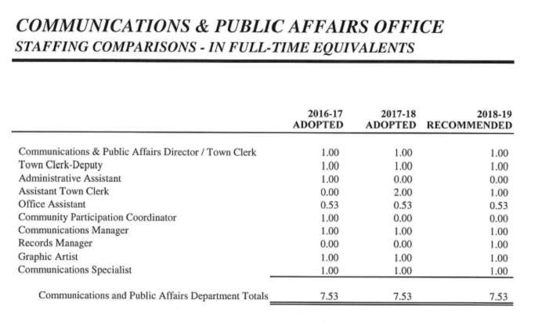

Most Town communications staff are in Communications and Public Affairs office. In addition to the Director, who oversees both communications and Town clerk functions, there are two communications staff. The Graphic Artist provides support to the Town’s communications and web services.  The balance of the positions in CAPA are primarily responsible for Town clerk functions such as Council meetings and advisory board support.

There is a communication specialist in public safety, who coordinated with CAPA communications staff as well as an individual in the Library and Transit, who have a role in providing communications support to those functions. All staff with a communications element to their job coordinate with our Communications Manager in CAPA to support the Town’s strategic messaging.