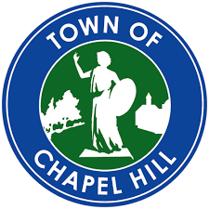 Council Committee on Boards and Commissions
August 26, 2021 10:00 AM
Virtual Meeting

Agenda
- Welcome ---Mayor Hemminger
- Approval/Additions to Agenda –Mayor Hemminger
- Informational Updates –Anita Badrock, Ombuds
  - Status of Advisory Board New Member Orientation
  - Update on Proposed Leadership Meeting for Selected Boards and Commissions
    - Planning
    - Board of Adjustment
    - Community Design Commission
    - Historic District Commission
  - Reviewing Board Charges
- Discussion and New Business—Mayor Hemminger
  - Draft Proposal on Petition Process for Petitions Presented by Council Members
  - Stormwater Utility Advisory Board Membership Criteria Discussion
- Adjourn

