Stream Team Spring Habitat Assessment

# Guided Journal

|  |
| --- |
| This journal provides an opportunity for you to collect all of your reflections from reading the Volunteer Handbook and/or attending the in-person How to Read a Creek session.  You can take this journal out to the field with you to take further notes on how to conduct a Stream Habitat Assessment. |

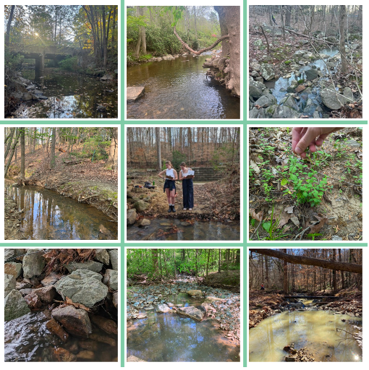

# **Before You Begin**

# Where can I learn about Habitat Assessments?

The information about Habitat Assessments begins in the [Volunteer Handbook](https://www.townofchapelhill.org/home/showpublisheddocument/54760/638466987497270000)[1] on page 32 with the section called “The Habitats: Get to Know Our Creeks.”

We will also cover this information in Spring training during the in-person How to Read a Creek session. But, if you cannot attend, reading the handbook sections on Habitat Assessments, answering the questions in this journal and completing the suggested tasks will serve as an asynchronous substitute.

# Concept 1: Local Geology

### Task 1: After reading the section titled "What is the local geology?” in your Volunteer Handbook (pg. 32), visit the interactive map on The Geology of North Carolina. Write below whether your site is in the Triassic Basin or Carolina Terrane. Name one characteristic you might expect in your stream because of its geologic history.

# Concept 2: Watersheds

### Task 2: Read the section titled “What are the watersheds in Chapel Hill?” in your Volunteer Handbook (pg. 33). How would you explain what a watershed is to a friend or family member?

### Task 3: Identify the three major watersheds in Chapel Hill. What river basin is Chapel Hill in?

# Concept 3: Stream Types

### Task 4: Read the section titled “What are the different types of streams?” in your Volunteer Handbook (pg. 35). What category of stream is your site a part of?

#### Hint: Open the Stream Team Monitoring Sites Web Map and make sure the “Streams” layer is activated. Find your site and click on the stream. Look for “Flow Type” in the stream’s data.

# Concept 4: Subwatersheds

### Task 4: Use the Stream Team Monitoring Sites Web Map to view the Town subwatersheds map layer. Which subwatershed does your site call home?

# Concept 5: Stream Processes and Components

### Task 5: Read the section titled “How do streams work?” (pp. 36-39). Write about one human activity that impacts streams. Name the stream process and component(s) of the living stream environment that are affected by this activity.

# Concept 6: Urban Stream Stressors

### Task 6: Read the section titled “What are urban stream stressors?” (pp. 40-41) Describe a time you observed at least one of these stressors.

# Concept 7: Water Color

### Task 7: Read the section titled “Water Color” (pp. 41-44). What is the best way to assess stream color?

### Task 8: List one stream color that may be cause for concern. Why might it be a problem? Who will you contact if you see this color at your site?

# Concept 8: Water Surface

### Task 9: Read the section titled “Water Surface” (pp. 45-48). How do you determine whether an oily sheen is natural or a cause for concern?

### Task 10: How do you determine whether foam is natural or a cause for concern?

# Concept 9: Basic Visuals

### Task 11: You now have at least two seasons of experience answering the basic visuals questions in the Stream Team Field Survey. Which of these visuals, if any, would you like more training on?

# Concept 10: Habitat Assessment

### Task 12: After reading the sections on Habitat Assessment and How to Fill out the Stream Habitat Assessment Survey (p. 48), discuss one reason why annual habitat assessments are important. Why do you think we suggest assessing the habitat each Spring?

# Concept 11: Rocky vs Muddy Bottom Streams

### Task 13: Is your site a rocky or muddy bottom stream?

#### Hint: use the information provided in the section “Rocky vs Muddy Bottom Streams” (p. 48) and Local Geology (pp. 32-33) to answer this question

# Concept 12: Scoring the Parameters

### Task 14: In the section “Scoring the Parameters,” (p. 49), we suggest that all teammates complete the habitat assessment individually, then come to a consensus on the final score. Do you expect a lot of variation between your teammates’ scores? Why or why not?

# Concept 13: Epifaunal Substrate

### Task 15: The first habitat parameter you will evaluate is epifaunal substrate. After reading the section on epifaunal substrate (pp. 49-50), describe what you should look for when evaluating this parameter.

### Task 16: Why is epifaunal substrate important?

# Concept 14: Embeddedness

### Task 17: The next habitat parameter you will evaluate is epifaunal substrate. After reading the section on embeddedness (pp. 50-51), describe what you should look for when evaluating this parameter.

### Task 18: Why is embeddedness important?

# Concept 15: Riffle/Run/Pools

### Task 19: The next habitat parameter you will evaluate is the diversity of riffles, runs, and pools at your site. After reading the section on riffles, runs, and pools (pp. 51-52), describe what you should look for when evaluating this parameter.

### Task 20: Why are riffle, runs, and pools important?

# Concept 16: Sediment Deposition

# Task 21: The next habitat parameter you will evaluate is sediment deposition at your site. After reading the section on sediment deposition (pp. 52-53), describe what you should look for when evaluating this parameter.

### Task 22: Why is sediment deposition important?

# Concept 17: Channel Flow Status

### Task 23: The next habitat parameter you will evaluate is the channel flow status at your site. After reading the section on channel flow status (pp. 53-54), describe what you should look for when evaluating this parameter.

### 

### 

### 

### 

### 

### 

### 

### Task 24: Why is channel flow status important?

# Concept 18: Channel Alteration

### Task 25: The next habitat parameter you will evaluate is channel alteration at your site. After reading the section on channel alteration (pp. 54-55), describe what you should look for when evaluating this parameter.

### 

### 

### 

### 

### 

### 

### 

### Task 26: Why is evaluating channel alteration important?

# Concept 19: Channel Sinuosity

### Task 27: If you have a muddy bottom site, the next habitat parameter you will evaluate is channel sinuosity at your site. After reading the section on channel sinuosity (pp. 55-56), describe what you should look for when evaluating this parameter.

### 

### 

### Task 28: Why is channel sinuosity important?

# Concept 20: Bank Stability

### Task 29: The next habitat parameter you will evaluate is bank stability. After reading the section on bank stability (pp. 56-57), describe what you should look for when evaluating this parameter.

### Task 30: Why is bank stability important?

# Concept 21: Vegetative Protection

### Task 31: The next habitat parameter you will evaluate is vegetative protection. After reading the section on vegetative protection (p. 58), describe what you should look for when evaluating this parameter.

### Task 32: Why is vegetative protection important?

# Concept 22: Riparian Vegetative Zone Width

### Task 33: The next habitat parameter you will evaluate is riparian vegetative zone width. After reading the section on riparian vegetative zone width (p. 59), describe what you should look for when evaluating this parameter.

### Task 34: Why is riparian vegetative zone width important?

# Concept 23: Spotting and Identifying Non-Native Vegetation

### Task 35: We have included some of the most common non-native, invasive plants in Chapel Hill in the section titled “Spotting and Identifying Non-Native Vegetation” (pp. 59-61). Did anything in this section surprise you? Are there any plants you suggest we add to this list?

### Task 36: Why is nonnative vegetation problematic?

# Concept 24: Interpreting Habitat Scores

### Task 37: Once you evaluate all the parameters, you will add up the values to get a total score between 0-90. The section “Interpreting Habitat Scores” (p. 61) provides an overview of what your total score means. In which range do you expect your site to score? Why?

### Task 38: Do you expect much variation in the total score at your site over time? Why or why not?

1. <https://www.townofchapelhill.org/home/showpublisheddocument/54760/638466987497270000>