Stream Team Training Guided Journal

Fall 2024

Use this journal to take notes from the Volunteer Handbook, watching the videos posted on the Stream Team website, and/or attending the in-person Fall Stream Team Training.

You can take this journal out to the field with you to take further notes on how to assess and record basic visuals, pH, conductivity, and dissolved oxygen.

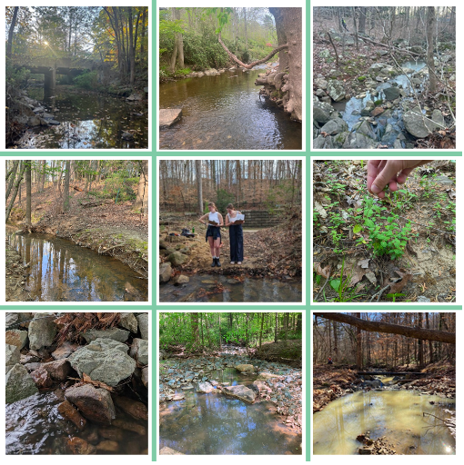

Before You Begin

What resources are available for volunteers?
The Stream Team website (www.townofchapelhill.org/streamteam) has the information you will need to get started with Stream Team:
- You can find a link to the Volunteer Handbook under the section ‘What resources are available for volunteers?’ This section also has a Water Quality Parameters 101 Video Series, which outline the parameters you will be measuring and how to calibrate your equipment.
- The past report is in the section, ‘What do the data say about stream health?’
- After the in-person training, you will receive a copy of the slide deck via email.

Section 1: Stream Team Basics

Concept 1: About the Program

Task 1: After listening to staff introduce Stream Team at training or reading the Volunteer Handbook section “The Beginning: How We Got Here” (pages 3-4), write one reason why Stream Team exists.

Task 2: The Volunteer Handbook subsection “Welcome to Stream Team!” outlines your responsibilities as a Stream Team volunteer (pg. 3). What are your 4 main responsibilities as a Stream Team volunteer?

Concept 2: Stream Team Data Quality

Task 3: During the training, staff discussed data tiers for volunteer water quality monitoring programs. This information is also provided in the section “What are the data tiers for water quality monitoring?” in the Volunteer Handbook (pg. 4). What kind of program is Stream Team 2.0?
- Tier 1
- Tier 2
- Tier 3

Task 4: What does the data tier you selected mean?

Hint: What can the data you collect be used for? What can the data NOT be used for?

Task 5: How does the data tier associated with Stream Team 2.0 affect your responsibility as a volunteer?

Concept 3: Program Staff Information

Task 6: During Fall training, staff shared contact information with you. This information can also be found in the Volunteer Handbook in the subsection “Who do we contact with questions and feedback?” (pg. 4). Who should you contact with questions? What is their email address?

Task 7: Who do you contact in case of emergency in the field? This was discussed during the safety portion of training and is also mentioned in the Volunteer Handbook on page 4.

Hint: This answer should be different from your answer above.

Concept 4: A Deeper Dive into Your Site

Task 8: When you were welcomed to Stream Team, you were assigned a site. You can find this information in your inbox (subject line: “Welcome to the Stream Team (Site # ) Which site were you assigned?

Task 9: We briefly discussed the sites at training. There is also information about the sites on pages 7-17 of the Volunteer Handbook, and at the bottom of the Stream Team website (townofchapelhill.org/streamteam) under the “Where are the 10 sites?”. Is your site one of the Tier 3 bug monitoring sites?
□ Yes □ No

Task 10: Why are you excited about monitoring this site?

Concept 5: Communicating and Assigning Roles within Your Team

Task 11: When you were welcomed to Stream Team, you were included on an email thread with the rest of your team (subject line: “Welcome to the Stream Team (Site # ). Write your team’s contact information here in case you lose this email thread.

Task 12: There are 10 teams, but for now, the Stream Team program only has 5 monitoring kits. This means that 5 teams monitor during the first half of the monitoring month (we call this ‘Batch 1’) and 5 teams monitor during the second half of the monitoring month (we call this ‘Batch 2’). Now that you are in contact with your team, you can either meet up at the Fall training or communicate over email (or another method chosen by your team) to decide when you will monitor. Which batch will your team be a part of?
- Batch 1 – we will monitor during the first half of the monitoring month
- Batch 2 – we will monitor during the second half of the monitoring month

Task 13: Your team has several responsibilities beyond attending training and monitoring quarterly. Pages 26-27 of the Volunteer Handbook outlines the additional tasks your team will need to complete throughout the year. Spend a few moments during training or, if you couldn’t attend training, communicate with your team over email to decide who will lead each task. Write the tasks you will be leading below.

Section 2: The Parameters—What We’re Measuring
The information you will need to complete this section of the journal can be found in a variety of places.
During training, staff will lead a discussion about the different parameters you will be measuring.
You can learn basic information about the parameters by watching the Water Quality Parameters 101 Video Series, which are linked on the Stream Team website (townofchapelhill.org/streamteam) under “What resources are available for volunteers?”
There is also detailed information about the different parameters under the section “The Parameters: What We’re Measuring” of the Volunteer Handbook (pp. 18-21).

Task 14: Which water quality parameters will you measure as a Stream Team volunteer?

Hint: Stream Team volunteers measure 4 water quality parameters.

Concept 6: Water Temperature and Streams

Task 15: After reviewing the resources provided to complete this section, please explain in your own words how temperature affects water quality and why it is important to consider temperature in our analyses of the Stream Team sites.

Task 16: Which equipment will you use to measure temperature at your site?

Hint: This information was discussed at training and can be found on page 29 of the Volunteer Handbook in the section “What supplies are in the Stream Team kits?” The calibration videos on the Stream Team website under the section “What resources are available for volunteers?” and the handbook section “How and when do we calibrate the equipment?” also contain this information.

Concept 7: Dissolved Oxygen ("DO")

Task 17: After reviewing the resources provided to complete this section, please explain in your own words how dissolved oxygen, or DO, affects water quality and why it is important to consider DO in our analyses of the Stream Team sites.

Task 18: What is the typical DO level in Chapel Hill streams?

Hint: This information can be found in the “Dissolved Oxygen (DO)” section of the Volunteer Handbook (pg. 18).

Task 19: What is the concerning range for DO levels in Chapel Hill streams?

Hint: This information can be found in the “Dissolved Oxygen (DO)” section of the Volunteer Handbook (pg. 18).

Task 20: What is the 'report immediately’ range for DO levels in Chapel Hill streams?

Hint: This information can be found in the “Dissolved Oxygen (DO)” section of the Volunteer Handbook (pg. 18).

Task 21: Which equipment will you use to measure dissolved oxygen (DO) at your site?

Hint: This information was discussed at training and can be found on page 29 of the Volunteer Handbook in the section “What supplies are in the Stream Team kits?” The calibration videos on the Stream Team website under the section “What resources are available for volunteers?” and the handbook section “How and when do we calibrate the equipment?” also contain this information.

Concept 8: pH (the power of Hydrogen)

Task 22: After reviewing the resources provided to complete this section, please explain in your own words how pH, or the power of Hydrogen, affects water quality and why it is important to consider pH in our analyses of the Stream Team sites.

Task 23: What is the typical pH level in Chapel Hill streams?

Hint: This information can be found in the “pH (power of Hydrogen)” section of the Volunteer Handbook (pg. 20).

Task 24: What is the concerning range for pH levels in Chapel Hill streams?

Hint: This information can be found in the “pH (power of Hydrogen)” section of the Volunteer Handbook (pg. 20).

Task 25: What is the 'report immediately’ range for pH levels in Chapel Hill streams?

Hint: This information can be found in the “pH (power of Hydrogen)” section of the Volunteer Handbook (pg. 20).

Task 26: Which equipment will you use to measure pH (power of Hydrogen) at your site?

Hint: This information was discussed at training and can be found on page 29 of the Volunteer Handbook in the section “What supplies are in the Stream Team kits?” The calibration videos on the Stream Team website under the section “What resources are available for volunteers?” and the handbook section “How and when do we calibrate the equipment?” also contain this information.

Concept 9: Electrical Conductivity

Task 27: After reviewing the resources provided to complete this section, please explain in your own words how electrical conductivity affects water quality and why it is important to consider conductivity in our analyses of the Stream Team sites.

Task 28: What is the typical electrical conductivity level in Chapel Hill streams?

Hint: This information can be found in the “Electrical Conductivity” section of the Volunteer Handbook (pg. 20).

Task 29: What is the concerning range for electrical conductivity levels in Chapel Hill streams?

Hint: This information can be found in the “Electrical Conductivity” section of the Volunteer Handbook (pg. 20).

Task 30: What is the 'report immediately’ range for electrical conductivity levels in Chapel Hill streams?

Hint: This information can be found in the “Electrical Conductivity” section of the Volunteer Handbook (pg. 20).

Task 31: Which equipment will you use to measure electrical conductivity at your site?

Hint: This information was discussed at training and can be found on page 29 of the Volunteer Handbook in the section “What supplies are in the Stream Team kits?” The calibration videos on the Stream Team website under the section “What resources are available for volunteers?” and the handbook section “How and when do we calibrate the equipment?” also contain this information.

Concept 10: Quality Assurance and Control Requirements

Task 32: Where will you go for information if you forget how to calibrate one of your meters?

Task 33: What will you do if you have consulted the resource above and are still having difficulties calibrating the equipment?

Hint: Remember our QA/QC obligations because of the Stream Team program’s data tier. Do not proceed with monitoring without resolving calibration difficulties.

Concept 11: Data Use

Task 34: After attending Fall training and/or reading through the Volunteer Handbook section “What can the data tell us about stream health?” (pg. 25-26), answer the following questions.

During which year did Stream Team volunteers collect baseline data for the 10 sites?

Why might results differ between the 10 sites? Discuss at least 2 factors contributing to variation.

Why is it important to compare results for individual sites over time, rather than comparing the sites to each other?

Section 3: The Protocols: How to Use the Equipment and Submit the Data

Concept 13: Preparing for Monitoring

Task 35: During Task 13, you selected a teammate who is responsible for picking up your kit. Where can this teammate find information about what is in the kits so that they can double check that you have all of the equipment needed for monitoring?

Hint: There is a checklist with all of the equipment, and it exists in two places.

Task 36: During Task 13, you selected a teammate who is responsible for calibrating the equipment. For many teams, it makes sense for this to be the same person that picks up the equipment. When should this person calibrate the equipment?

Hint: You can find this information in the Volunteer Handbook section “How and when do we calibrate the equipment?” (pp. 30).

Concept 14: Field Safety

Task 36: Your safety is the most important part of Stream Team! You are responsible for your own safety. We discussed field safety during training, and there is a section for field safety in your Volunteer Handbook on page 27. What steps will you take to make sure you are safe in the field?

Concept 15: Analyzing Basic Visuals and Collecting Samples

The information needed to complete this section of the journal was discussed in Fall training and can also be found in the Volunteer Handbook section “How and when do we collect samples?” (pg. 31-32).

Task 37: After attending training and/or reading the Volunteer Handbook section “How and when do we collect samples?”, you should have a good understanding of what a riffle is. Please describe riffles in your own words and why it is important to find a riffle at your site.

Task 38: What should you do if you cannot find a riffle, or if the flow is too low to monitor at your site?

Task 39: Fill in the blanks in the Water Color table.

The completed table can be found in the handbook, pages 42-46. There is also a quick reference guide laminated in your kits.
Description | What Might This Look Like? | When Should I Be Concerned?
Brown/Muddy | This stream is brown because it is full of ______________________.  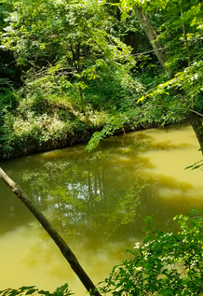  This stream is muddy because of an _____________ from a construction site. Report ____________________.  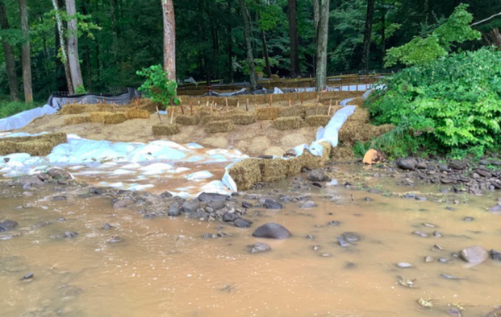 | Brown, muddy streams are a sign of _______________________, so turbid streams are ________ concerning and important to note these observations.  We should be especially concerned if we see a lot of sediment when it ____________________ and/or if we see a _________________ (i.e. construction site) directly releasing sediment into the stream.
Green | This stream is green because of a ________________________________. Report immediately.  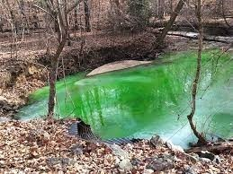  This is an __________________________. Report immediately. 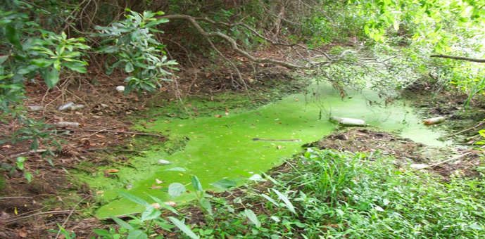  This stream is green because of _________________________________. Take a photo and submit it in your field survey. 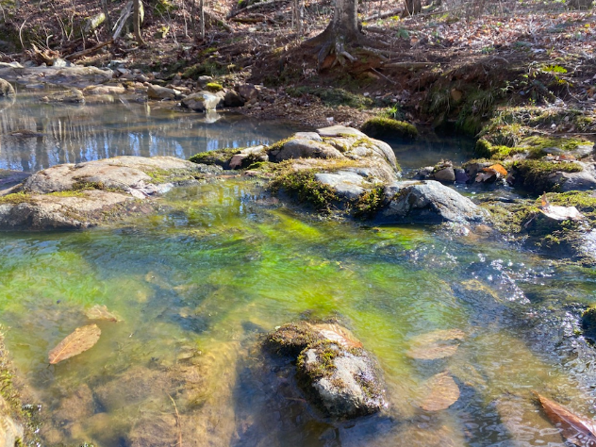 | Streams can be green for several reasons. The three most concerning reasons are:  - __________________________________ like paint or antifreeze  - __________________________________, which are caused by excess nutrient pollution  - ____________, which can grow when there is nutrient pollution and hot air/water temperatures.  It is always important to document green streams in your field survey.  If you see an algal bloom or what appears to be a chemical in the stream, call ______________________.
Milky/White | Milky, white stream water.  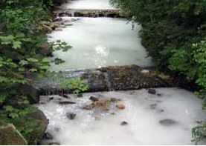 | Milky/white stream water is ______________________. It is most often caused by _____________________________________________________________________.  If you see a milky/white stream, report it immediately to _______________________.
Tannic/Tea | Tannic/tea-colored stream water.  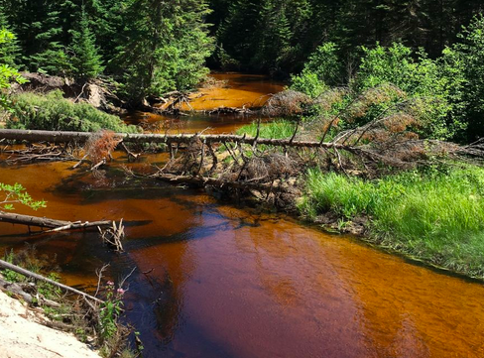 | Brown, tea-colored water can be confused with ____________________________________________., but it is a bit different.  In contrast to brown, muddy streams, tannic streams are ____________and brown.  This can be caused by decaying organic material (plants, leaves, tree trunks). The decaying material sometimes releases ____________, which are _______________________occurring chemicals found in some plants.  It is important to note that tannins are acidic, so you can expect a ___________ pH reading if you observe tannic/tea-colored water.  While tannins are natural, tannic/tea-colored water is _________________ in Chapel Hill, so be sure to note it and submit a photo in your field survey if you observe this at your site.

Task 40: Fill in the blanks in the Water Surface table.

The completed table can be found in the handbook, pages 46-49. There is also a quick reference guide laminated in your kits.
Description | What Might This Look Like? | When Should I Be Concerned?
Clear/Normal | Clear, normal streams are a sign of __________ stream health.  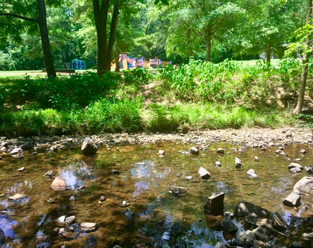  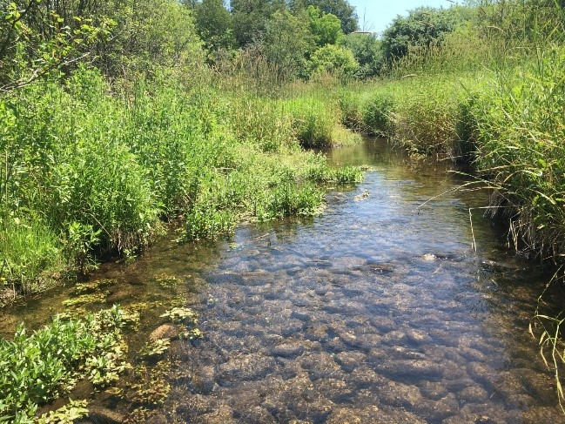 | If your stream is clear and there is nothing unusual on the surface, that’s _________!
Oily Sheen | A sheen caused by __________________________________.  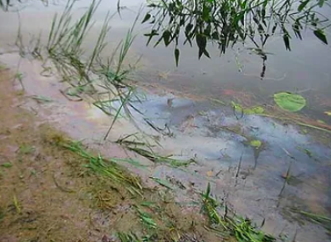  _______________________________ breaking apart when poked.  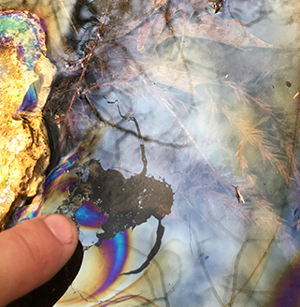 | Everyone's first thought is an oil spill, but that's not always true. Iron-oxidizing bacteria is ____________________in Chapel Hill.  A bacterial sheen can usually be distinguished from a petroleum sheen by attempting to _______________________ the sheen.  When a stick is poked in to a bacterial sheen or a stone is dropped in to it, the sheen will typically ______________________________________________.  In contrast, a petroleum sheen will quickly ______________________________________________after any disturbance. If you encounter this, _________________________________________.
Algae | ________________on the surface of the water.  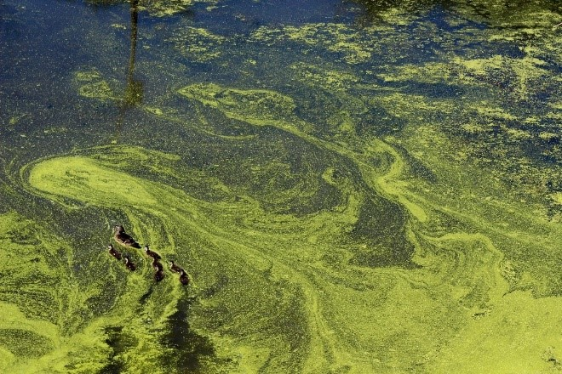 | Algae is caused by _______________________ and is exacerbated by _______ temperatures. If you see algae on the surface of the stream, note it in your field survey and ________________________________________.
Foam | _____________________________ foam gathered on a limb.  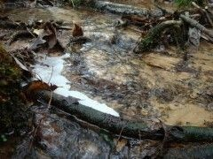  This may look alarming, but it is also _________________________________ and no cause for concern.  This is ______________________ foam. If you see this, report it immediately.  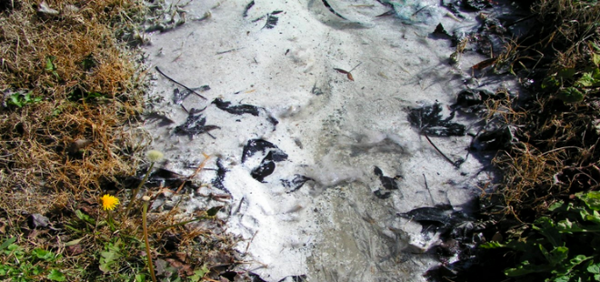 | Foam can be alarming to see, but it is not always a cause for concern. If you observe foam, always note it in your survey and submit a photo.  Foam produced from ______________________________________ is identified by its off-white color and its “fishy” or “earthen” odor. Buildups are more prevalent after rainfall.  __________________________________________ is usually a pure white color and tends to smell fragrant (the product of detergent discharge) or unpleasant (the product of sanitary sewer or septic field failures).  If you suspect the foam is ____________________________________________, report it immediately to Stormwater and do not try to remove the foam yourself.

Task 41: Where can you find information about how to take pH, conductivity, DO, and temperature readings at your site?

Task 42: How do you submit data?

Hint: This information can be found in the Volunteer Handbook section “How do we submit data?” (pg. 33).

Task 43: Where can you find the data?

Hint: This information can be found in the Volunteer Handbook section “Where do we find the data?” (pg. 33).

