## CR-05 - Goals and Outcomes

**Progress the jurisdiction has made in carrying out its strategic plan and its action plan. 91.520(a)**

This could be an overview that includes major initiatives and highlights that were proposed and executed throughout the program year.

The Five Year Consolidated Plan is a guide for Orange County and the Town of Chapel Hill to use for its housing, community development, and economic programs and initiatives. This is the third year of the 2015-2019 Consolidated Plan. The progress accomplished towards addressing each Strategic Plan Goals is shown below.

**Comparison of the proposed versus actual outcomes for each outcome measure submitted with the consolidated plan and explain, if applicable, why progress was not made toward meeting goals and objectives. 91.520(g)**

Categories, priority levels, funding sources and amounts, outcomes/objectives, goal outcome indicators, units of measure, targets, actual outcomes/outputs, and percentage completed for each of the grantee’s program year goals.

|  |  |  |  |  |  |  |  |  |  |  |
| --- | --- | --- | --- | --- | --- | --- | --- | --- | --- | --- |
| **Goal** | **Category** | **Source / Amount** | **Indicator** | **Unit of Measure** | **Expected – Strategic Plan** | **Actual – Strategic Plan** | **Percent Complete** | **Expected – Program Year** | **Actual – Program Year** | **Percent Complete** |
| AM-1 Overall Coordination | Non-Housing Community Development | CDBG: $ | Other | Other | 1 | 1 | 100.00% | 1 | 1 | 100.00% |
| CD-1 Community Facilities | Non-Housing Community Development | CDBG: $ | Public Facility or Infrastructure Activities other than Low/Moderate Income Housing Benefit | Persons Assisted | 0 | 0 |  |  |  |  |
| CD-1 Community Facilities | Non-Housing Community Development | CDBG: $ | Public Facility or Infrastructure Activities for Low/Moderate Income Housing Benefit | Households Assisted | 0 | 0 |  |  |  |  |
| CD-1 Community Facilities | Non-Housing Community Development | CDBG: $ | Other | Other | 0 | 0 |  | 0 | 0 |  |
| CD-2 Infrastructure | Non-Housing Community Development | CDBG: $ | Public Facility or Infrastructure Activities for Low/Moderate Income Housing Benefit | Households Assisted | 0 | 0 |  |  |  |  |
| CD-3 Public Services | Non-Housing Community Development | CDBG: $ | Public service activities other than Low/Moderate Income Housing Benefit | Persons Assisted | 500 | 266 | 53.20% | 53 | 53 | 100.00% |
| CD-3 Public Services | Non-Housing Community Development | CDBG: $ | Public service activities for Low/Moderate Income Housing Benefit | Households Assisted | 0 | 0 |  |  |  |  |
| CD-3 Public Services | Non-Housing Community Development | CDBG: $ | Homeless Person Overnight Shelter | Persons Assisted | 0 | 33 |  | 14 | 14 | 100.00% |
| CD-3 Public Services | Non-Housing Community Development | CDBG: $ | Overnight/Emergency Shelter/Transitional Housing Beds added | Beds | 0 | 0 |  | 0 | 0 |  |
| CD-4 Code Enforcement | Non-Housing Community Development | CDBG: $ | Public Facility or Infrastructure Activities for Low/Moderate Income Housing Benefit | Households Assisted | 0 | 0 |  |  |  |  |
| CD-4 Code Enforcement | Non-Housing Community Development | CDBG: $ | Homeowner Housing Added | Household Housing Unit | 0 | 0 |  |  |  |  |
| CD-4 Code Enforcement | Non-Housing Community Development | CDBG: $ | Homeowner Housing Rehabilitated | Household Housing Unit | 0 | 0 |  |  |  |  |
| CD-4 Code Enforcement | Non-Housing Community Development | CDBG: $ | Housing for Homeless added | Household Housing Unit | 0 | 0 |  |  |  |  |
| CD-4 Code Enforcement | Non-Housing Community Development | CDBG: $ | Housing for People with HIV/AIDS added | Household Housing Unit | 0 | 0 |  |  |  |  |
| CD-4 Code Enforcement | Non-Housing Community Development | CDBG: $ | Housing Code Enforcement/Foreclosed Property Care | Household Housing Unit | 100 | 34 | 34.00% | 69 | 69 | 100.00% |
| CD-5 Clearance | Non-Housing Community Development |  | Buildings Demolished | Buildings | 0 | 0 |  |  |  |  |
| CD-6 Revitalization | Affordable Housing Public Housing Non-Housing Community Development | CDBG: $383379 | Public Facility or Infrastructure Activities other than Low/Moderate Income Housing Benefit | Persons Assisted | 0 | 0 |  |  |  |  |
| CD-6 Revitalization | Affordable Housing Public Housing Non-Housing Community Development | CDBG: $383379 | Public Facility or Infrastructure Activities for Low/Moderate Income Housing Benefit | Households Assisted | 0 | 0 |  |  |  |  |
| CD-6 Revitalization | Affordable Housing Public Housing Non-Housing Community Development | CDBG: $383379 | Public service activities for Low/Moderate Income Housing Benefit | Households Assisted | 0 | 0 |  |  |  |  |
| CD-6 Revitalization | Affordable Housing Public Housing Non-Housing Community Development | CDBG: $383379 | Homeowner Housing Rehabilitated | Household Housing Unit | 0 | 0 |  | 1 | 1 | 100.00% |
| CD-6 Revitalization | Affordable Housing Public Housing Non-Housing Community Development | CDBG: $383379 | Buildings Demolished | Buildings | 0 | 0 |  | 0 | 0 |  |
| CD-6 Revitalization | Affordable Housing Public Housing Non-Housing Community Development | CDBG: $383379 | Other | Other | 0 | 0 |  | 5 | 5 | 100.00% |
| ED-1 Employment | Non-Housing Community Development |  | Jobs created/retained | Jobs | 1 | 1 | 100.00% |  |  |  |
| ED-2 Financial Assistance | Non-Housing Community Development |  | Businesses assisted | Businesses Assisted | 0 | 0 |  |  |  |  |
| ED-3 Redevelopment Program | Non-Housing Community Development |  | Public Facility or Infrastructure Activities other than Low/Moderate Income Housing Benefit | Persons Assisted | 0 | 0 |  |  |  |  |
| ED-3 Redevelopment Program | Non-Housing Community Development |  | Public Facility or Infrastructure Activities for Low/Moderate Income Housing Benefit | Households Assisted | 0 | 0 |  |  |  |  |
| ED-3 Redevelopment Program | Non-Housing Community Development |  | Public service activities other than Low/Moderate Income Housing Benefit | Persons Assisted | 0 | 0 |  |  |  |  |
| ED-3 Redevelopment Program | Non-Housing Community Development |  | Public service activities for Low/Moderate Income Housing Benefit | Households Assisted | 0 | 0 |  |  |  |  |
| ED-3 Redevelopment Program | Non-Housing Community Development |  | Facade treatment/business building rehabilitation | Business | 0 | 0 |  |  |  |  |
| ED-3 Redevelopment Program | Non-Housing Community Development |  | Businesses assisted | Businesses Assisted | 0 | 0 |  |  |  |  |
| HO-1 Continnum of Care | Homeless | CDBG: $ | Homelessness Prevention | Persons Assisted | 100 | 0 | 0.00% |  |  |  |
| HO-2 Operation/Support | Homeless | CDBG: $ | Homelessness Prevention | Persons Assisted | 100 | 66 | 66.00% |  |  |  |
| HS-1 Housing Rehabilitation | Affordable Housing Public Housing | CDBG: $ | Rental units rehabilitated | Household Housing Unit | 15 | 0 | 0.00% |  |  |  |
| HS-1 Housing Rehabilitation | Affordable Housing Public Housing | CDBG: $ | Homeowner Housing Rehabilitated | Household Housing Unit | 25 | 5 | 20.00% | 11 | 11 | 100.00% |
| HS-3 Fair Housing | Affordable Housing |  | Other | Other | 1 | 0 | 0.00% |  |  |  |
| HS-4 Homeownership | Affordable Housing | CDBG: $ | Homeowner Housing Added | Household Housing Unit | 0 | 1 |  | 1 | 1 | 100.00% |
| HS-4 Homeownership | Affordable Housing | CDBG: $ | Direct Financial Assistance to Homebuyers | Households Assisted | 20 | 5 | 25.00% |  |  |  |
| HS-5 Public Housing | Affordable Housing Public Housing Homeless Non-Housing Community Development | CDBG: $ | Public Facility or Infrastructure Activities for Low/Moderate Income Housing Benefit | Households Assisted | 0 | 0 |  |  |  |  |
| HS-5 Public Housing | Affordable Housing Public Housing Homeless Non-Housing Community Development | CDBG: $ | Rental units rehabilitated | Household Housing Unit | 80 | 0 | 0.00% |  |  |  |
| HS-5 Public Housing | Affordable Housing Public Housing Homeless Non-Housing Community Development | CDBG: $ | Homeowner Housing Rehabilitated | Household Housing Unit | 0 | 0 |  |  |  |  |
| SN-3 Accessibility | Affordable Housing Non-Homeless Special Needs |  | Public service activities for Low/Moderate Income Housing Benefit | Households Assisted | 0 | 0 |  |  |  |  |
| SN-3 Accessibility | Affordable Housing Non-Homeless Special Needs |  | Rental units rehabilitated | Household Housing Unit | 0 | 0 |  |  |  |  |
| SN-3 Accessibility | Affordable Housing Non-Homeless Special Needs |  | Homeowner Housing Rehabilitated | Household Housing Unit | 0 | 0 |  |  |  |  |

Table 1 - Accomplishments – Program Year & Strategic Plan to Date

**Assess how the jurisdiction’s use of funds, particularly CDBG, addresses the priorities and specific objectives identified in the plan, giving special attention to the highest priority activities identified.**

2017 CDBG programming included operational support for homeless case management;  a summer employment program for LMI youths; code enforcement in specific target areas in Town (Northside and Pine Knolls); minor home repair for LMI homeowners in target areas; support for affordable housing and community development; and support for home acquisition to lower the cost of homes to LMI homebuyers.

## CR-10 - Racial and Ethnic composition of families assisted

**Describe the families assisted (including the racial and ethnic status of families assisted). 91.520(a)**

|  |  |
| --- | --- |
|  | **CDBG** |
| White | 9 |
| Black or African American | 39 |
| Asian | 1 |
| American Indian or American Native | 0 |
| Native Hawaiian or Other Pacific Islander | 0 |

|  |  |  |
| --- | --- | --- |
|  |  | |
| **Total** | **49** |

|  |  |  |
| --- | --- | --- |
|  |  | |
| Hispanic | 3 |
| Not Hispanic | 46 |

**Table 2 – Table of assistance to racial and ethnic populations by source of funds**

**Narrative**

## CR-15 - Resources and Investments 91.520(a)

**Identify the resources made available**

|  |  |  |  |
| --- | --- | --- | --- |
| **Source of Funds** | **Source** | **Resources Made Available** | **Amount Expended During Program Year** |
| CDBG | CDBG | 904,721 | 701,425 |
| HOME | HOME |  |  |
| HOPWA | HOPWA |  |  |
| ESG | ESG |  |  |
| Other | Other |  |  |

Table 3 - Resources Made Available

**Narrative**

**Identify the geographic distribution and location of investments**

|  |  |  |  |
| --- | --- | --- | --- |
| **Target Area** | **Planned Percentage of Allocation** | **Actual Percentage of Allocation** | **Narrative Description** |
| Northside Neighborhood | 4 | 59 | Northside activities included: code enforcement, property acquisition, and home repair programs. |
| Pine Knolls Neighborhood | 3 | 6 | Pine KNolls activities included code enforcement and home repair programs. |
| Public Housing Neighborhood | 4 | 13 |  |
| Town-wide | 89 | 22 |  |

Table 4 – Identify the geographic distribution and location of investments

**Narrative**

2017 CDBG funded activities include 2 public service programs, 2 home owner rehabilitation programs, property acquisition/homeownership program, Code Enforcement, and Administration. Code enforcement, neighborhood revitalization, property acquisition, and homeowner rehabilitation programs were focused in the target areas of Northside and Pine Knolls while a few projects were completed town-wide.

**Leveraging**

**Explain how federal funds leveraged additional resources (private, state and local funds), including a description of how matching requirements were satisfied, as well as how any publicly owned land or property located within the jurisdiction that were used to address the needs identified in the plan.**

Since fiscal year 14-15, the Town Council has annually allocated over $688,000 for affordable housing. In March 2015 the Council approved an allocation strategy for this funding, establishing an Affordable Housing Development Reserve (AHDR). The AHDR is dedicated exclusively to the development and preservation of affordable housing.

In 2016-2017, the Town identified a Town-owned property (Homestead Road) as a site for affordable housing development. Since then, the Town Council has adopted a resolution formally setting the property aside for affordable housing development; the Town has performed a stream determination and a Phase I Environmental Assessment and Asbestos inspection, and has contracted with a development consultant and architectural design firm.  In the winter of 2018, a concept plan for development of this parcel was submitted.  The Town is in the process of identifying community/development partners and seeking private grants and additional resources for the development of the site.

In past Community Surveys, the issue of affordable housing consistently receives high dissatisfaction ratings among Chapel Hill residents. The Chapel Hill 2020 Plan set a goal to create a range of housing options for current and future residents. Partnering with nonprofit housing providers like DHIC to develop a low income housing tax credit project on Town-owned land was the top recommendation identified in the Affordable Rental Housing Strategy adopted by the Council in February 2014. The Town has partnered with the Raleigh nonprofit DHIC Inc. to create two rental communities– Greenfield Place, 80 apartments for working families, and Greenfield Commons, up to 69 units for senior citizens, on an approximately 9 acre property located on an undeveloped portion of the Chapel Hill Memorial Cemetery off Legion Road.  Greenfield Place is now open and fully occupied, while Greenfield Commons is under construction with an anticipated opening in early 2019.

## CR-20 - Affordable Housing 91.520(b)

**Evaluation of the jurisdiction's progress in providing affordable housing, including the number and types of families served, the number of extremely low-income, low-income, moderate-income, and middle-income persons served.**

|  | One-Year Goal | Actual |
| --- | --- | --- |
| Number of Homeless households to be provided affordable housing units | 0 | 0 |
| Number of Non-Homeless households to be provided affordable housing units | 0 | 0 |
| Number of Special-Needs households to be provided affordable housing units | 0 | 0 |
| **Total** | **0** | **0** |

Table 11 – Number of Households

|  | One-Year Goal | Actual |
| --- | --- | --- |
| Number of households supported through Rental Assistance | 0 | 0 |
| Number of households supported through The Production of New Units | 0 | 0 |
| Number of households supported through Rehab of Existing Units | 16 | 11 |
| Number of households supported through Acquisition of Existing Units | 2 | 1 |
| **Total** | **18** | **12** |

Table 12 – Number of Households Supported

**Discuss the difference between goals and outcomes and problems encountered in meeting these goals.**

With aging housing stock, there is an increase in the amount of work needed and funds needed for rehab, which results in a reduced number of units.

**Discuss how these outcomes will impact future annual action plans.**

We will continue to set goals that seem reasonable, at the time of submitting future annual action plans.

**Include the number of extremely low-income, low-income, and moderate-income persons served by each activity where information on income by family size is required to determine the eligibility of the activity.**

|  |  |  |  |
| --- | --- | --- | --- |
| **Number of Households Served** | **CDBG Actual** | **HOME Actual** | |
| Extremely Low-income | 2 | 0 |
| Low-income | 2 | 0 |
| Moderate-income | 8 | 0 |
| **Total** | **12** | **0** |

Table 13 – Number of Households Served

**Narrative Information**

**Narrative Information**

(2) <30% AMI homeowners assisted was with home repairs

(2) 31-50% AMI homeowners were assisted with home repairs

(7) 51-80% AMI homeowners were assisted with home repairs

(1) 51-80% LMI homebuyer

## CR-25 - Homeless and Other Special Needs 91.220(d, e); 91.320(d, e); 91.520(c)

**Evaluate the jurisdiction’s progress in meeting its specific objectives for reducing and ending homelessness through:**

**Reaching out to homeless persons (especially unsheltered persons) and assessing their individual needs**

Through the Town's CDBG program, funding was allocated to the Inter-Faith Council to support homeless case management. Throughtout the 2017 program year, over 1976 hours of case managemetn services were provided, and 14 homeless women and families were assisted with shelter, securing housing, and connecting with support services.

**Addressing the emergency shelter and transitional housing needs of homeless persons**

In 2015, with ongoing support from the Town, the Inter-Faith Council opened a 52-bed men's transitional Community House facility. The Inter-Faith Council also operates Project HomeStart, a shelter for homeless women and their children located a half-mile from Community House. In 2017, IFC provided 9,320 bednights through the HomeStart program.

**Helping low-income individuals and families avoid becoming homeless, especially extremely low-income individuals and families and those who are: likely to become homeless after being discharged from publicly funded institutions and systems of care (such as health care facilities, mental health facilities, foster care and other youth facilities, and corrections programs and institutions); and, receiving assistance from public or private agencies that address housing, health, social services, employment, education, or youth needs**

The Inter-Faith Council helped enroll 14 homeless women and families in ongoing case management including connecting them to mental health services, primary care, mainstream benefits, and assist them in successfully securing affordable housing (through Rapid Rehousing and Permanent Supportive Housing programs), in the 2017 program year.

**Helping homeless persons (especially chronically homeless individuals and families, families with children, veterans and their families, and unaccompanied youth) make the transition to permanent housing and independent living, including shortening the period of time that individuals and families experience homelessness, facilitating access for homeless individuals and families to affordable housing units, and preventing individuals and families who were recently homeless from becoming homeless again**

Effective May 1, 2015, the Town’s public housing admissions policies were modified to include Homelessness persons as a local preference priority for public housing applicant selection.

Consistent with the Council’s goal statement of the Affordable Housing Strategy,  (“increase the affordability of and access to housing for households and individuals with a range of incomes, from those who are homeless to those in middle-income households.”) we have added “homeless” individuals and families to the local preference selection criteria for the public housing waiting list. This addition to the local preference policy would allow homeless individuals and families to receive priority on the housing waiting list along with applicants who are employed, elderly or disabled. Though this change may not house applicants immediately, it could provide housing to households that are experiencing homelessness more quickly than the Town’s current admissions policy provides.

## CR-30 - Public Housing 91.220(h); 91.320(j)

**Actions taken to address the needs of public housing**

We have reorganized the Public Housing department to improve our capacity to carry out our mission and better align staff functions.  We have a new director in place, as well as additional management and maintenance staff, filling previously vacant positions.  The inter-departmental Resident Services Team has continued to develop and provide programming for our public housing residents. We continue to offer programs such as computer literacy, cooking classes, and family reading, after school programming at the Community Connect Center in the South Estes Drive community. We have also focused our efforts on launching the Resident Leadership Team that would serve as a liaison between public housing residents and our staff.  We also have a Public Housing Master Plan underway, which will include an evaluation of our portfolio of public housing units and options for redevelopment.  We anticipate presenting the master plan to the Town Council in the winter of 2018.

**Actions taken to encourage public housing residents to become more involved in management and participate in homeownership**

The Transitional Housing program is designed to prepare public housing families for the move to homeownership and private market housing. The basic design builds upon the concept of putting a family into a house and replicating the private market environment. During a family’s tenure in the program, they are responsible for many of the tasks they will encounter when they move out of subsidized housing. However, during their tenure, the Housing Department provides a safety net of resources to enhance their ability to successfully make and prepare for the transition. The Town of Chapel Hill has purchased three homes for the program.  The homes are located outside of the Town’s conventional public housing neighborhoods, as will all homes purchased for use in the program. Program participants have up to 5 years to prepare for the move to the private market. The Town’s goal is to have 10 homes over the course of 5 years. The Town added 1 single-family residence to the program in 2017-2018, and anticipate adding at least 4 more units in 2018-2019.

**Actions taken to provide assistance to troubled PHAs**

## CR-35 - Other Actions 91.220(j)-(k); 91.320(i)-(j)

**Actions taken to remove or ameliorate the negative effects of public policies that serve as barriers to affordable housing such as land use controls, tax policies affecting land, zoning ordinances, building codes, fees and charges, growth limitations, and policies affecting the return on residential investment. 91.220 (j); 91.320 (i)**

* Conducting a review and rewrite of the Town’s Land Use Management Ordinance
* Instituted a few waiver policy for affordable housing development
* Created a new zoning district to allow more flexibility for affordable housing development
* Increase the educational opportunities and provide training relating to Fair Housing through workshops, forums and presentations
* Target specific protected groups for fair housing information
* Continue to consult with local lending institutions
* Provide training to housing providers and consumers about their obligations and rights.
* Continue to work with the County and Town governments to develop appropriate legislation and ordinances to assist with the development of affordable housing
* Monitor and track the Inclusionary Zoning Ordinance enacted by the Town of Chapel Hill for effectiveness in the development of affordable housing and utilize as a model ordinance for adoption by the Towns of Carrboro and Hillsborough and Orange County for implementation if positive results are determined.

**Actions taken to address obstacles to meeting underserved needs. 91.220(k); 91.320(j)**

We have hired a consultant to provide the Town with a market and needs analysis, an analysis of available financial resources and strategies for housing development, an affordability gap analysis, options for new revenue sources for affordable housing, and an economic impact analysis and policy recommendations.

**Actions taken to reduce lead-based paint hazards. 91.220(k); 91.320(j)**

**Actions taken to reduce the number of poverty-level families. 91.220(k); 91.320(j)**

Since fiscal year 14-15, the Town Council has annually allocated over $688,000 for affordable housing.  In March, 2015 the Council approved an allocation strategy for this funding, establishing an Affordable Housing Development Reserve (AHDR). The AHDR is dedicated exclusively to the development and preservation of affordable housing. This year (FY17-18), the Town Council allocated an additional $450,000 for the AHDR, or $1.13 million total available through this funding source.

**Actions taken to develop institutional structure. 91.220(k); 91.320(j)**

We have reorganized the Public Housing department to improve our capacity to carry out our mission and better align staff functions.

**Actions taken to enhance coordination between public and private housing and social service agencies. 91.220(k); 91.320(j)**

Our relationship with our affordable housing partners is stronger than ever. We are working together in different ways to further the Town’s affordable housing goals. We continue to be an active participant in the Orange County Affordable Housing Coalition and we have engaged local housing providers in different ways. We have renewed our commitment to work closely with our partners in a coordinated manner and we look forward to the exciting projects that we will accomplish together.  In collaboration with the Coalition, we recently developed a county-wide inventory of all subsidized housing. For the first time, we have detailed information about all subsidized units throughout Orange County.  We are currently exploring ways to share this data with the community and use this information to inform future affordable housing priorities and opportunities for collaboration.

**Identify actions taken to overcome the effects of any impediments identified in the jurisdictions analysis of impediments to fair housing choice. 91.520(a)**

## CR-40 - Monitoring 91.220 and 91.230

**Describe the standards and procedures used to monitor activities carried out in furtherance of the plan and used to ensure long-term compliance with requirements of the programs involved, including minority business outreach and the comprehensive planning requirements**

Throughout the year, Town staff monitored and evaluated individual programs' progress towards contracted goals and expenditures. Agencies are required to submit regular quarterly or semi-annual program activity, financial, and contract compliance reports.  This information was used to monitor program activity and contract compliance with all regulations, including administrative, financial, and programmatic operations.  Timely expenditure of funds was a component of these monitoring activities.

**Citizen Participation Plan 91.105(d); 91.115(d)**

**Describe the efforts to provide citizens with reasonable notice and an opportunity to comment on performance reports**.

The Town of Chapel Hill’s draft CAPER was made available to the public on August 15-31, 2018, along with instructions about how to provide input. A notice was published in the Herald Sun Legal Ads on July 29, August 5, and August 12, 2018 and published on the Town's website.There were no public comments received during the comment period. A final copy of the CAPER will be posted on the Town's website.

**CR-45 - CDBG 91.520(c)**

**Specify the nature of, and reasons for, any changes in the jurisdiction’s program objectives and indications of how the jurisdiction would change its programs as a result of its experiences.**

The Town of Chapel Hill made no significant changes to its program objectives from its amended 2017 Action Plan.

CDBG activities that have had a substantial impact on identified needs are the public services activities and affordable housing activities which were identified as high priority projects in the 2015-2020 Consolidated Plan. The indicators for CDBG need are identified by the type and number of applications received for funding in 2017. The Town has seen an increase in demand for the CDBG program funding. This increase of demand is reflected in the number of applications received and the increased amounts of funds being requested. Based upon the number of applications received, public services, homeownership assistance and housing rehabilitation are of the highest need.

2017 Funded activities include:  public service programs, neighborhood revitalization, homeowner rehabilitation programs, homeownership assistance program, code enforcement, and program administration.

**Does this Jurisdiction have any open Brownfields Economic Development Initiative (BEDI) grants?**

No

**[BEDI grantees] Describe accomplishments and program outcomes during the last year.**

**CR-45 - CDBG 91.520(c)**

**Specify the nature of, and reasons for, any changes in the jurisdiction’s program objectives and indications of how the jurisdiction would change its programs as a result of its experiences.**

The Town of Chapel Hill made no significant changes to its program objectives from its amended 2017 Action Plan.

CDBG activities that have had a substantial impact on identified needs are the public services activities and affordable housing activities which were identified as high priority projects in the 2015-2020 Consolidated Plan. The indicators for CDBG need are identified by the type and number of applications received for funding in 2017. The Town has seen an increase in demand for the CDBG program funding. This increase of demand is reflected in the number of applications received and the increased amounts of funds being requested. Based upon the number of applications received, public services, homeownership assistance and housing rehabilitation are of the highest need.

2017 Funded activities include:  public service programs, neighborhood revitalization, homeowner rehabilitation programs, homeownership assistance program, code enforcement, and program administration.

**Does this Jurisdiction have any open Brownfields Economic Development Initiative (BEDI) grants?**

No

**[BEDI grantees] Describe accomplishments and program outcomes during the last year.**

**Attachment**

**Town of Chapel Hill 2017 PR-026**

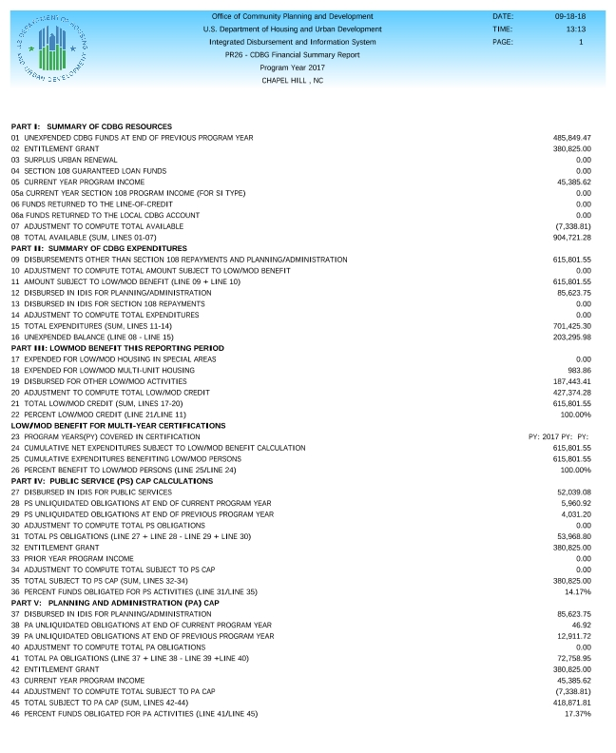

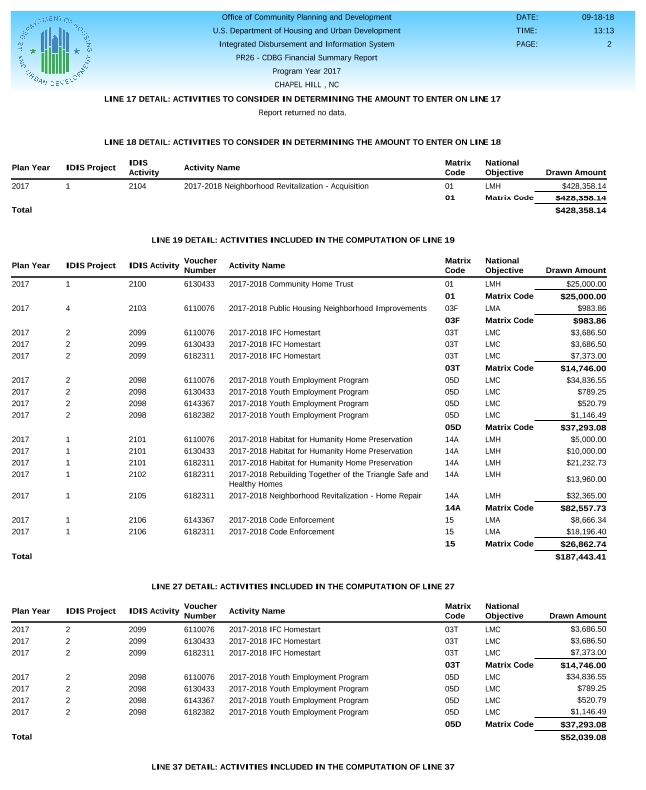

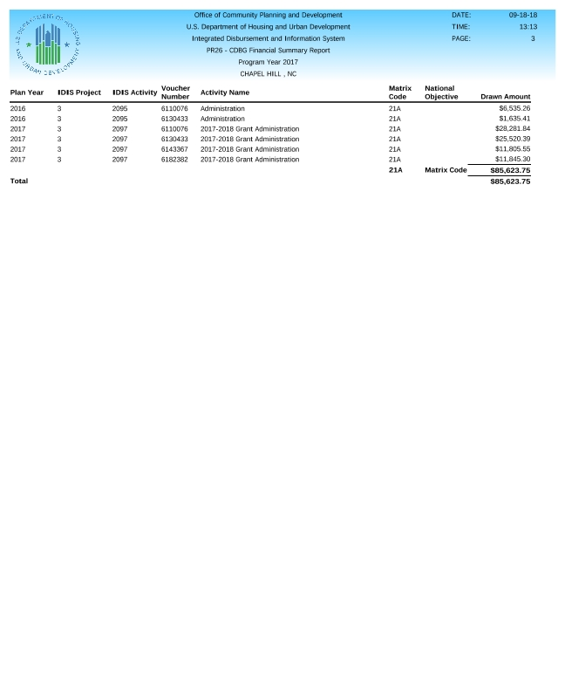

**Town of Chapel Hill 2017 CAPER Public Notice**

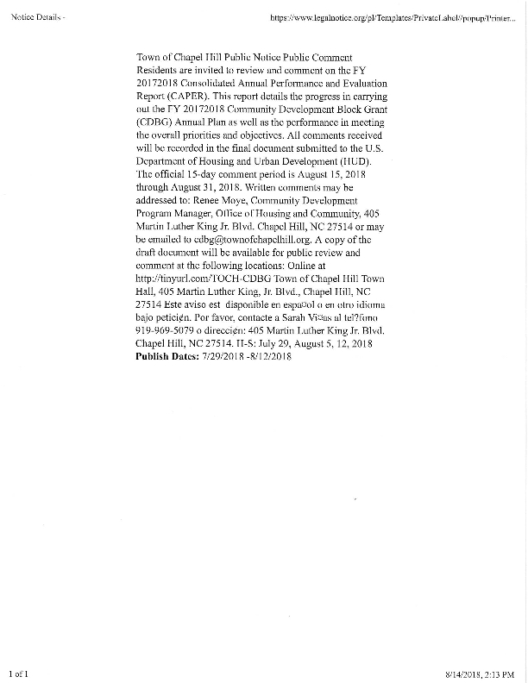

**Town of Chapel Hill 2017 CAPER Cover Page**

**Town of Chapel Hill 2017 WMBE**

